B.M.S College of Engineering

Bull Temple Road,

Bangalore-560019

DEPARTMENT OF INFORMATION SCIENCE & ENGINEERING



Course – PROGRAMMING WITH C++

Course Code – 16IS3DCPCP

DriveOut Car Rentals

Faculty Incharge – Mahalaxmi B.S

Submitted by –

Aishwarya Ramesh

(1BM16IS008)

Gehna Anand

(1BM16IS034)

Introduction

For a rental organization to function smoothly, we are creating an application using object oriented programming to help the user select his choice of car and dates from the variety of options provided to him.

# Problem Definition

The program will keep a record of cars in stock, available as rental, sorted by the number of people they seat. The user inputs the number of seats he needs in the car he wants to rent. The program then provides the cars available for rent by model name. The user chooses the car he wishes to rent and provides the dates for which he'll be using it. Once the user confirms the rental, a bill is printed

. Concepts Used

* Concept of classes and objects
* Static data members
* Hybrid inheritance
* Virtual Base classes
* Files
* Color coding

Tools Used

* Ubuntu
* Terminal
* Text Editor

Classes and objects

Classes are used so that a similar kind of data can be grouped in a structure.

Static data members

The various options of cars available in the three categories namely hatchbacks, sedans and SUVs have been made static.

Hybrid inheritance

Class car has been made the base class from which class hatchback, class sedan and class SUV have been publicly inherited. Another class rent which is used to display the rent publicly inherits properties from class hatchback, class sedan and class SUV.

Virtual Base classes

To prevent the duplication of data members during multiple inheritance, the classes hatchback sedan and SUV have been made virtual while being inherited by class rent.

Files

File is used to generate the bill of the car that the customer has rented.

Color coding

With the help of color coding, the user can identify the number of cars available in the store to rent.

HYBRID INHERITANCE

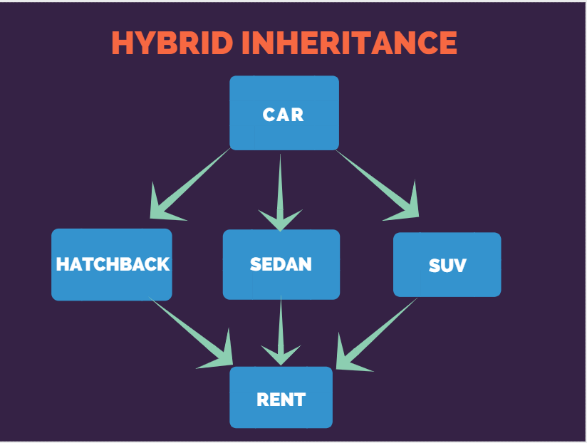

Flow diagram

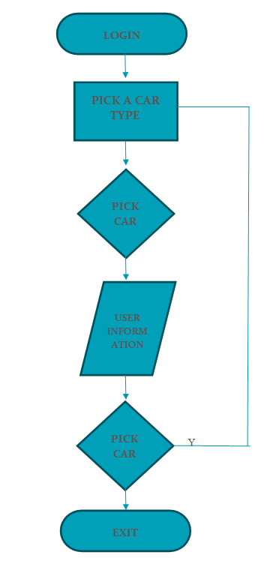

Snapshots

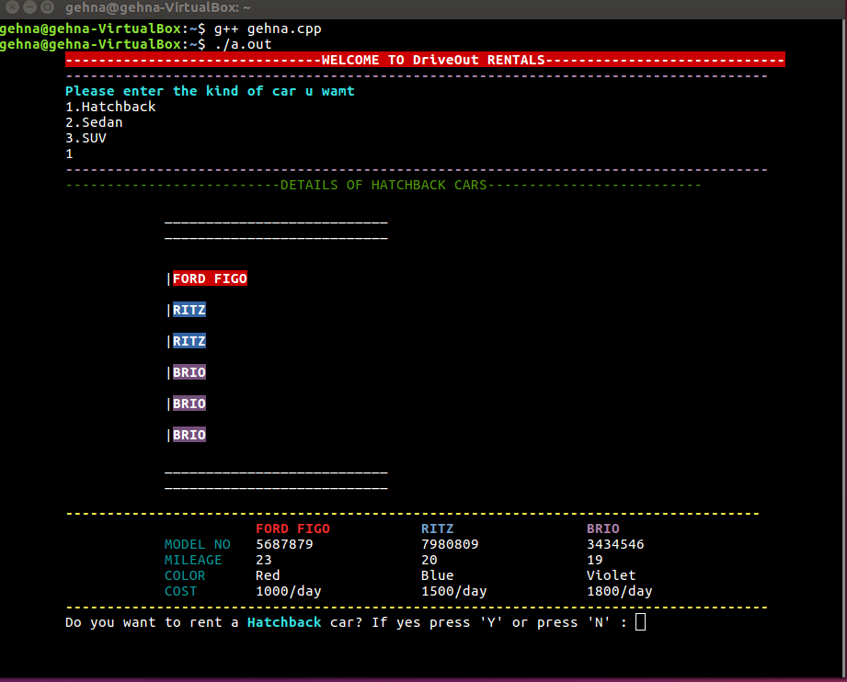

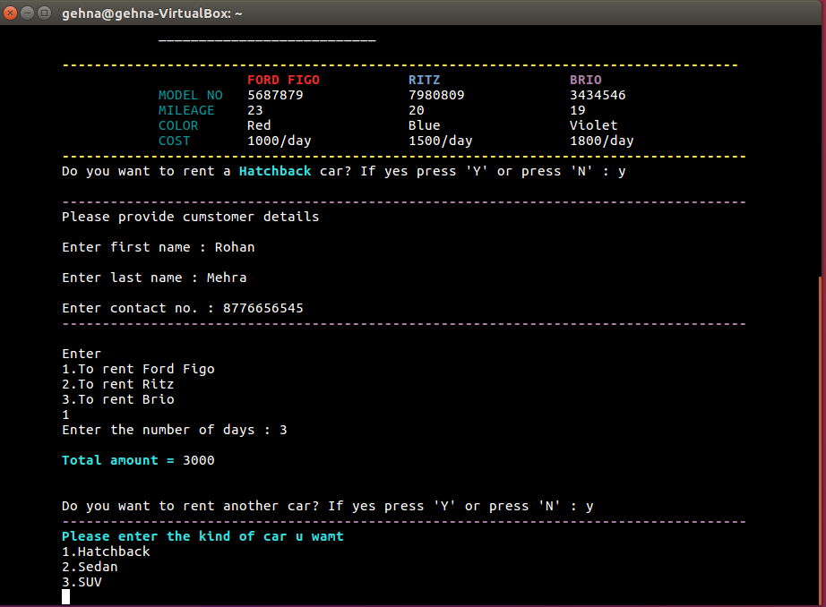

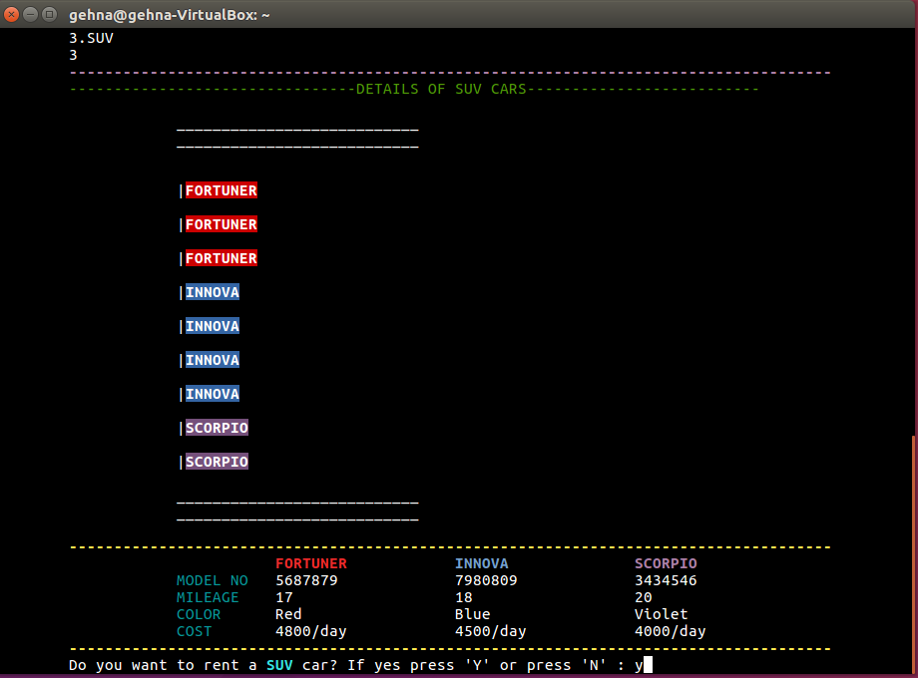

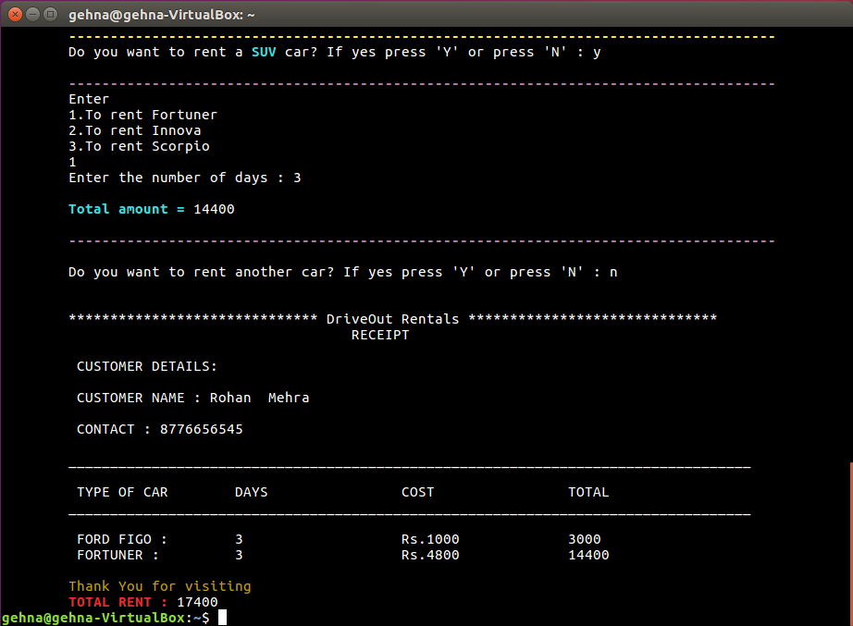

Conclusion

The above presented solution can be used to meet the brief of the problem definition. The code represents the dynamism of the language used by using features such as inheritance, static members and virtual base classes. The concept of color coding has also been demonstrated to make the interface more user friendly.

References

* Programming in C++ by Balaguruswamy
* [www.stackoverflow.com](http://www.stackoverflow.com)